

**DEPARTMENT: ELECTRICAL AND ELECTRONICS ENGINEERING**

**OPTION: ELECTRICAL TECHNOLOGY (ELT)**

**MODULE NAME: Programmable Ics Workshop**

**ACADEMIC YEAR: 2021-2022**

**Level: III**

**Stream B**

**SEMESTER: I**

TOPIC: CONTROLLING THE SPEED OF A MOTOR USING KEYPAD

KEYPAD

Designed by: NKINDI Ramadhan

MANZI Gilbert

**NAME OF MINI PROJECT: CONTROLLING THE SPEED OF A MOTOR USING KEYPAD**

**Abstract:**

This page describes a control system of dc motor according to speed of motor. This project included the keyboard input and LED display circuit control circuit dc motor work as actuator, resistor, Arduino uno board, transistor, bread board this all component will help us for implementing that circuit and also will be simulated in proteus software corresponding with program flow drawing. This system can be applied in many places for controlling the speed of dc motor the experiment showed that the system can be used stably and reliably in control speed of dc motor and perfect compliance with the requirements of project.[1]

**PROBLEM STATEMENT**

This technology of controlling the speed dc motor is used for performing many task in everyday life this technology can be used in this filed such as: in irrigation system for controlling the speed of pump, in industries, in blender machines and also there is many ways of controlling the speed of motor but this way is the most one which is digitalized compared and also it need few materials for to implement that will reduce the cost of that project.[2]

BLOCK DIAG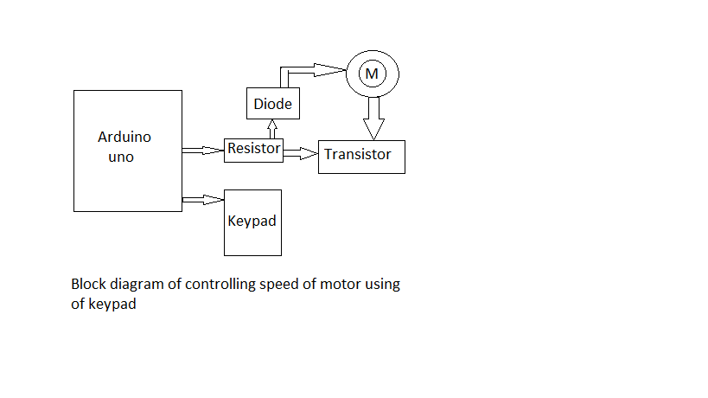

**DESCRIPTION:**

This project is composed with these components that are follow: Arduino Uno board, keypad, dc motor, resistor, ordinary diode, transistor, jumper wires as we see this component for one it can participate their function in the circuit.

Arduino uno board is the main component that will control all the circuit and Arduino it like the main switch, ordinary diode will work as like free-wheeling diode it will block the flow of power to Arduino, resistor will reduce much current that may cross to the circuit.

**1.Arduino:** is a prototype platform (open-source) based on an easy-to-use hardware and software. It consists of a circuit board, which can be programed (referred to as a microcontroller) and ready-made software called Arduino IDE (Integrated Development Environment), which is used to write and upload the computer code to the physical board.

Arduino is an open-source electronics platform based on easy-to-use hardware and software. Arduino boards are able to read inputs - light on a sensor, a finger on a button, or a Twitter message - and turn it into an output - activating a motor, turning on an LED, publishing something online.

[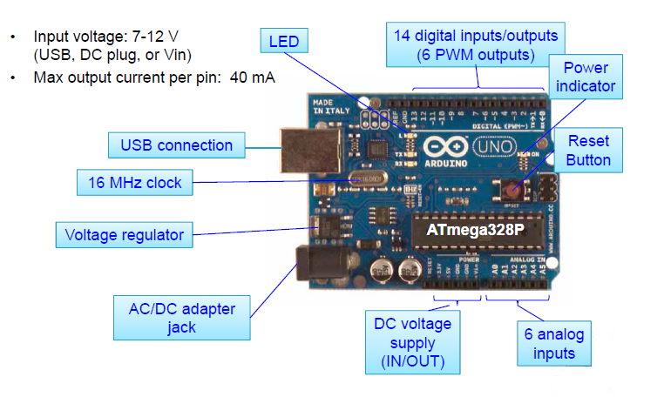](https://www.arduino.cc/en/Guide/Introduction)

**PIN DESCRIPTION**

**• Power connector:** This is where you power your Arduino when it's not plugged into a USB port for power. Can accept voltages between 7-12V.

• Reset Button: Resets the at mega microcontroller.

• USB port: Used for powering your Arduino Uno, uploading your sketches to your Arduino, and for communicating with your Arduino sketch.

• TX and RX LEDs: These LEDs indicate communication between your Arduino and your computer.

• Digital pins: Use these pins with digital-Read (), digital Write (), and analog Write (). analog Write () works only on the pins with the PWM symbol.

• Analog Pins: Use these pins with analogRead ().

• GND and 5V pins: Use these pins to provide +5V power and ground to your circuits.

• Pin 13 LED: The only actuator built-in to your Arduino Uno board.

• **ATmega microcontroller:** The heart of your Arduino Uno.

• **Power LED:** Indicates that your Arduino is receiving power. Useful for debugging

**2.DC motor:** is the motor which converts the direct current into the mechanical work. It works on the principle of Lorentz Law, which states that **“**the current carrying conductor placed in a magnetic and electric field experience a force”.

A Direct Current (DC) motor is a motor that turns energy from a direct current and turns this into mechanical energy. The first DC motor was developed around the 1830's-1840s.

Also is an electrical equipment that convert electrical energy into mechanical energy.

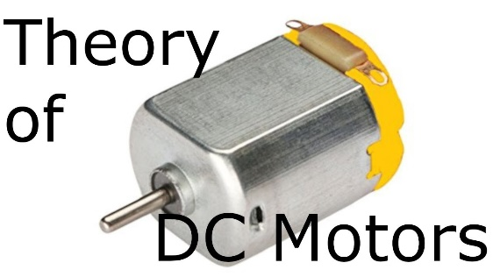

**3. Keypad:** is a numeric keypad which is used to separate set of keys on some keyboards that contain the numbers 0 through 9 and a decimal point arranged as on an adding machine.

Numeric keypads make it easier to enter large amounts of numeric data, and also

Keypads are found on devices which require mainly numeric input such as calculators, television remotes, push-button telephones, vending machines, ATMs, Point of Sale devices, combination locks, and digital door locks.

[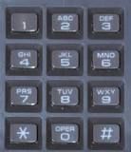](https://www.google.com/search?q=What+is+keypad+used+for?&tbm=isch&source=iu&ictx=1&vet=1&fir=1RE3bUfrJh6CiM%252CYte9ULO8e7cWjM%252C_&usg=AI4_-kQYLUNnAscmdkQeW_63ZEMrUZWvIg&sa=X&ved=2ahUKEwiM4JzP7Zf3AhVQ_7sIHU4MC2wQ9QF6BAgXEAE#imgrc=1RE3bUfrJh6CiM)

**4.Resistors:** are the most fundamental and commonly used component in all theelectronic circuits. The main function of a resistor within an electrical or electronic circuit is to oppose or resist the flow of current, hence named as resistor.

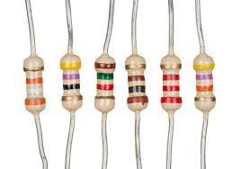

**5.A diode:** is a semiconductor device that essentially acts as a one-way switch for current. It allows current to flow easily in one direction, but severely restricts current from flowing in the opposite direction.

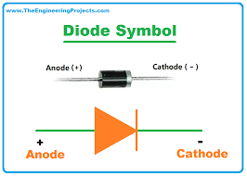

**6.Transistor:** semiconductor device for amplifying, controlling, and generating electrical signals. Transistors are the active components of integrated circuits, or “microchips,” which often contain billions of these minuscule devices etched into their shiny surfaces.

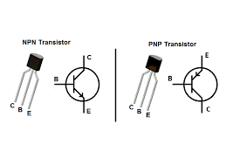

**7.Jumper wires:** are simply wires that have connector pins at each end, allowing them to be used to connect two points to each other without soldering. Jumper wires are typically used with breadboards and other prototyping tools in order to make it easy to change a circuit as needed.

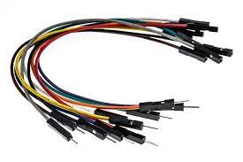

**FRITZING CIRCUIT**

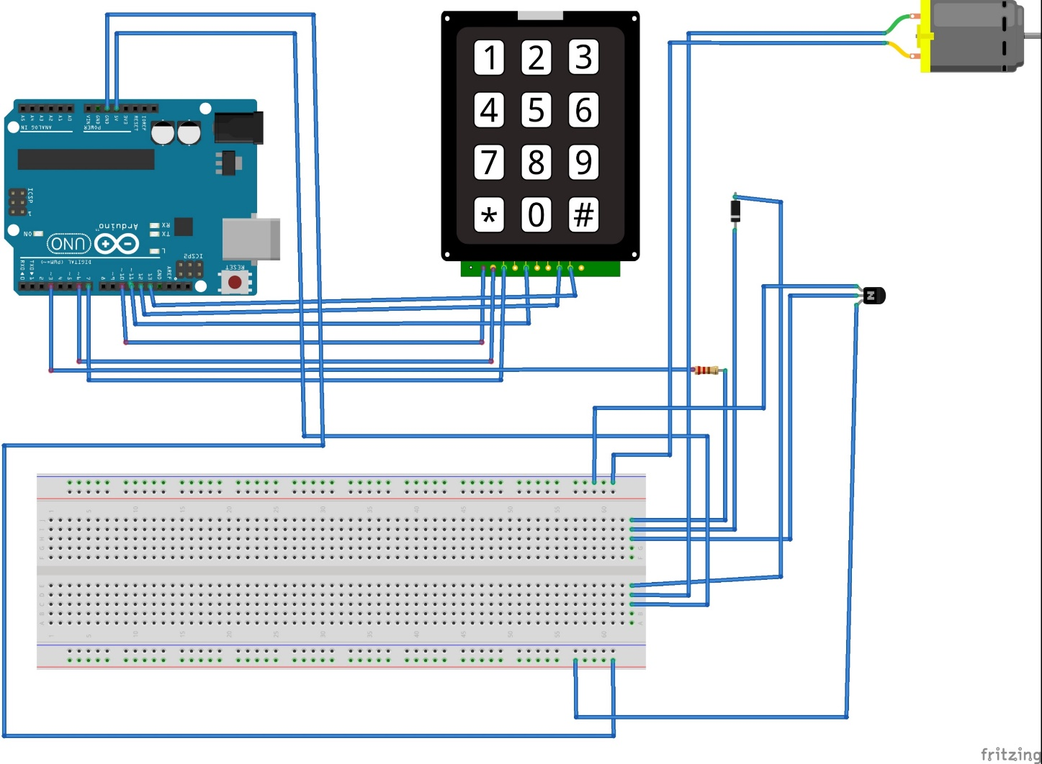

**SIMULATION IN PROTEUS**

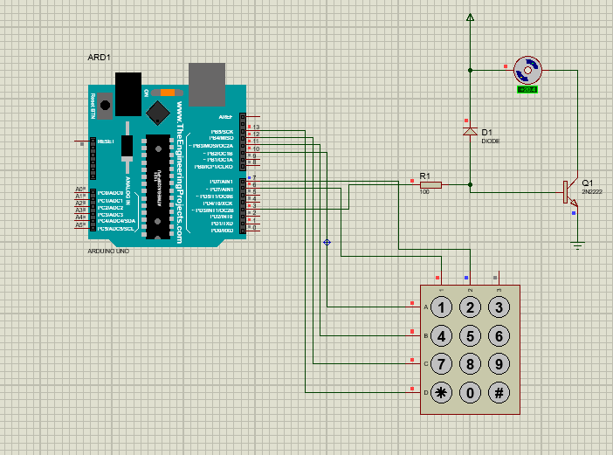

**SOURCE CODES IN ARDUINO IDE**

**#include <Keypad.h>**

**const int ROW_NUM = 4; //four rows**

**const int COLUMN_NUM = 3; //three columns**

**char keys[ROW_NUM][COLUMN_NUM] = {**

**{'1','2','3'},**

**{'4','5','6'},**

**{'7','8','9'},**

**{'*','0','#'}**

**};**

**byte pin_rows[ROW_NUM] = {9, 8, 7, 6}; //connect to the row pinouts of the keypad**

**byte pin_column[COLUMN_NUM] = {5, 4, 3}; //connect to the column pinouts of the keypad**

**Keypad keypad = Keypad( makeKeymap(keys), pin_rows, pin_column, ROW_NUM, COLUMN_NUM );**

**int pwm=3; // declares digital pin 3 as PWM output**

**int r1=6;**

**int r2=7;**

**int c1=10;**

**int c2=11;**

**int c3=12;**

**int c4=13;**

**int colm1;**

**int colm2;**

**int colm3;**

**int colm4;**

**void setup()**

**{**

**Serial.begin(9600);**

**pinMode(r1,OUTPUT);**

**pinMode(r2,OUTPUT);**

**pinMode(c1,INPUT);**

**pinMode(c2,INPUT);**

**pinMode(c3,INPUT);**

**pinMode(c4,INPUT);**

**pinMode(pwm,OUTPUT);**

**digitalWrite(c1,HIGH);**

**digitalWrite(c2,HIGH);**

**digitalWrite(c3,HIGH);**

**digitalWrite(c4,HIGH);**

**digitalWrite(pwm,LOW);**

**}**

**void loop()**

**{**

**digitalWrite(r1,LOW);**

**digitalWrite(r2,HIGH);**

**colm1=digitalRead(c1);**

**colm2=digitalRead(c2);**

**colm3=digitalRead(c3);**

**colm4=digitalRead(c4);**

**if(colm1==LOW) //checks whether key "1" is pressed.**

**{ analogWrite(pwm,30); // writes "42" (duty cycle 50%).**

**delay(200);}**

**else**

**{**

**if(colm2==LOW) //checks whether key "2" is pressed.**

**{ analogWrite(pwm,60); // writes "60" (duty cycle 60%).**

**delay(200);}**

**else**

**{**

**if(colm4==LOW) //checks whether key "4" is pressed**

**{analogWrite(pwm,90); // writes "90" (duty cycle 90%).**

**delay(200);}**

**else**

**{**

**if(colm4==LOW) // checks whether key"A" is pressed.**

**{digitalWrite(pwm,LOW); // makes pin 3 LOW (duty cycle 0%).Motor OFF.**

**delay(200);}**

**}}}**

**digitalWrite(r1,HIGH);**

**digitalWrite(r2,LOW);**

**colm1=digitalRead(c1);**

**colm2=digitalRead(c2);**

**colm3=digitalRead(c3);**

**colm4=digitalRead(c4);**

**if(colm1==LOW) // checks whether key "4" is pressed.**

**{analogWrite(pwm,168); //writes "168" (duty cycle 64%).**

**delay(200);}**

**else**

**{**

**if(colm2==LOW) // checks whether key "5" is pressed.**

**{analogWrite(pwm,202); // writes "202" (duty cycle 80%).**

**delay(200);}**

**else**

**{**

**if(colm3==LOW) // checks whether key "6" is pressed.**

**{analogWrite(pwm,244); // writes "244" (duty cycle 96%).**

**delay(200);}**

**else**

**{**

**if(colm4==LOW) // checks whether key "B" is pressed.**

**{digitalWrite(pwm,HIGH);//makes pin 3 HIGH (duty cycle 100%). FULL POWER**

**delay(200); }**

**}}}}**

**REFERENCE**

[1] M. S. S. Umadi and D. Patil, “DC MOTOR SPEED CONTROL USING Abstract :,” vol. 2, no. 6, pp. 70–74, 2016.

[2] A. U. Adoghe, S. O. Aliu, S. I. Popoola, and A. A. Atayero, “Digital Speed Control of DC Motor for Industrial Automation using Pulse Width Modulation Technique,” no. July, pp. 7–12, 2017.